{
"Monitor":{
"DeviceInfo":{
"DeviceMod":"PIR-V1.000",
"DeviceName":"As per name input in setup",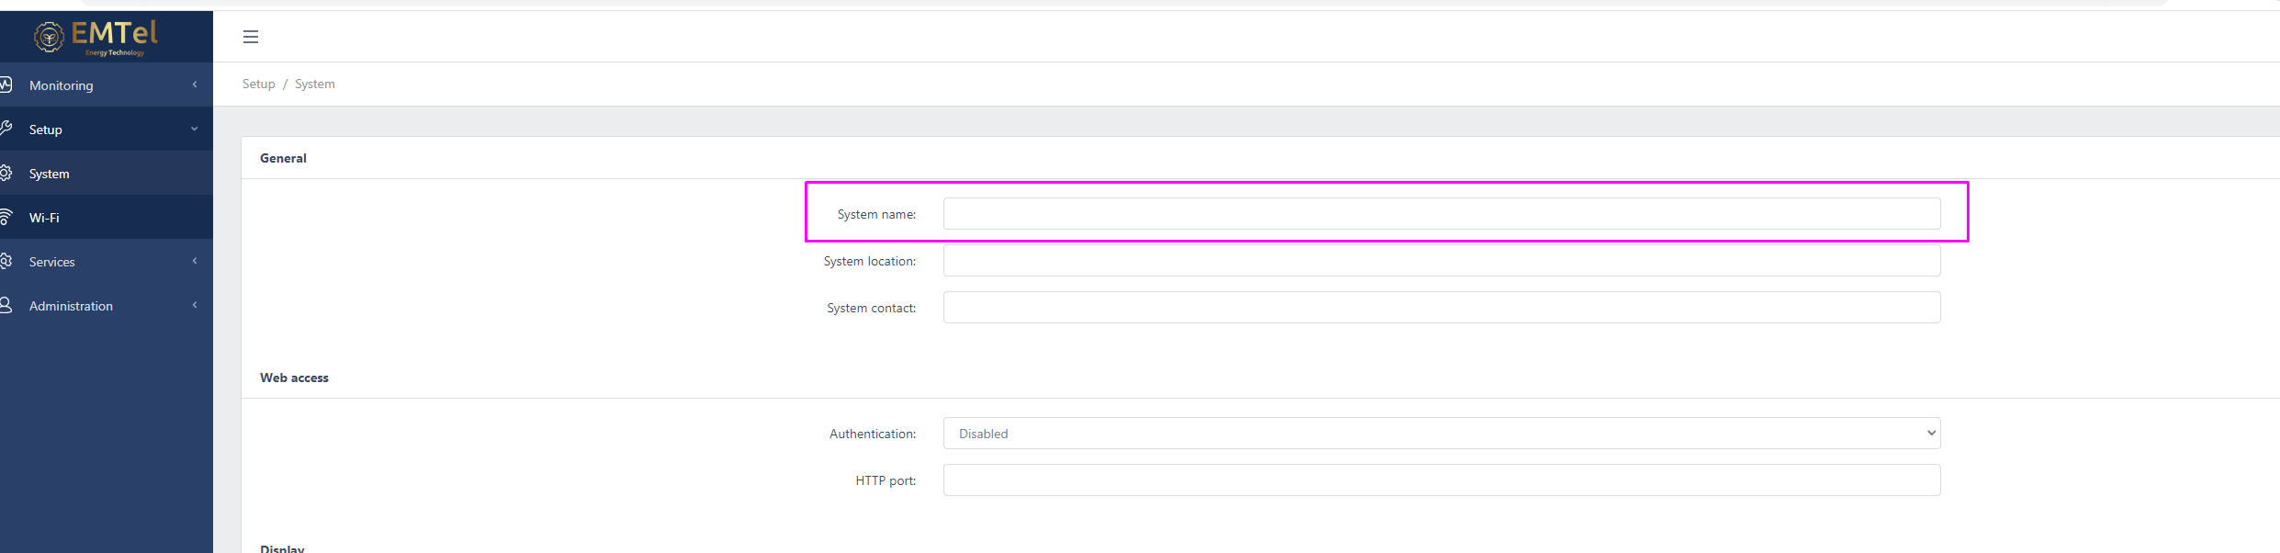
"ID":"24:0A:C4:AF:DF:98", we need to be able to assign our own mac id
"MainAppVer":"1.1.1.1", from the device
"MainBootVer":"1.1.1.1", from the device
"WiFi":{
"Ver":"1.3.5.8", from the device
"AP":{
"MAC":"24:0A:C4:AF:DF:99",
"State":1,
"Signal":19.5
},
"STA":{
"MAC":"24:0A:C4:AF:DF:98",
"State":1,
"Signal":-40
}
}
},
"CH":{
"CH1":{
"status":0, enabled = 1 or disabled = 0
"description":"Max Output",
"MO":100, As per setup This is in %
},
"CH2":{
"status":0, enabled = 1 or disabled = 0
"description":"Dimming",
"DI":25, As per setup this is in %
"DC":96, counter of cycles
"DA":0, dimming active = 1 dimming in standby = 0
},
"CH3":{
"status":0, enabled = 1 or disabled = 0
"description":"Time Out",
"TO":20, As per setup this is displayed in min
},
"CH4":{
"status":0, enabled = 1 or disabled = 0
"description":"Sensitivity",
"SY":85,As per setup This is in %
"SC":445, counter of cycles
},
"Time":{
"ts":946686273
}
}
}

ts - timestamp in unix format.

There should be four settings for the user inputs
By default, these should all be on and the following be the defaults
Max output: 100%
Dimming: 25%
Time out: 20 mins
Sensitivity: 100%

